The Creator

Team: Jeff Guo, Anthony Venturella, Sean Ennis

|  |  |
| --- | --- |
| Version Control | <https://github.com/JGuo99/cs426_The_Creator_Asgn6.git> |
| Bug Tracker | Github |
| Game Idea and Formal Elements | [Presentation Slides](https://docs.google.com/presentation/d/1FsrViMHNxgWDwLg5wbkz2ydFzUtcaItCnEiFVl8_TC4/edit?usp=sharing) |
| Task Manager and Calendar | Github Milestone |

**Overview:**

This is a player vs game interaction where the conflict is created by the player itself. Players will be placing planets along with setting the orbitals and select what to evolve first on habitable planets.

**Audience/Platform/Marketing:**

* Target Audience will be male and female that are over the age of 18
* This game will be developed for the desktop environment

**Characters:**

* There will only be one player itself along with AI characters.
* There are animated NPC’s on the planets to later showcase what evolution stage the planet is on.
* There’s a spaceship flying from planet to planet
* There’s a spaceship navigating through the asteroid belt

**Story:**

The higher being who created the original universe is now passing away. The player who is the descendant of the higher being is now tasked to continue the legacy of his/her predecessor.

**World:**

* Players will not be restricted to an area. They are able to move freely throughout the universe.
* There will be zones which are the planetary systems that the players can teleport to.

**Media List:**

* Sound Effects
* Thunder when near the gas planet
* Lava sound when near the lava planet
* Nature sound when near the terra planet

**UI Design:**

* **Detach Camera from Mouse;** “Minimizing Error Possibilities”

**( Can’t take picture of event)**

Was causing visual errors as player was unable to interact with objects after entering “click mode”.

* **Exit Button Text;** “Consistency”

 

*Before Alpha After Alpha*

Button text did not fit in with the theme of the game.

* **Exit Button Color;** “Clarity”

 

*Before Alpha After Alpha*

Button color was distracting as it didn’t follow the color scheme of the game.

* **Changing the enable and disable button for the mouse**; “Minimizing Error Possibilities”

**( Can’t take picture of event)**

Previously we used the tab key to show and right click to hide however this proved to be unintuitive and we went with tab for both.

* **Planet Zoom in sound for planets;** “Feedback” 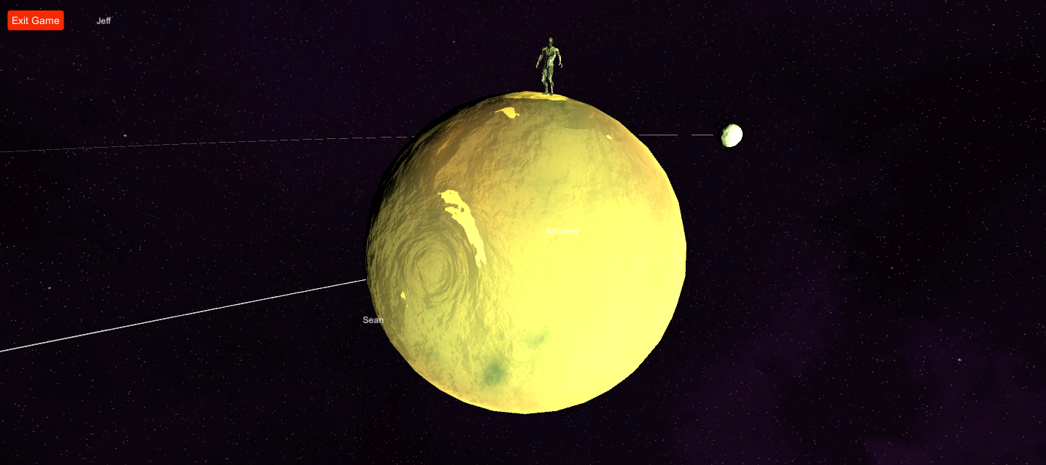

*(This effect now has sound to accompany it)*

Allows for immersion when clicking planets.

* **Click on planets**; “Minimizing Error Possibilities”

**( Can’t take picture of event )**

Changed up how we click on planets in order to make it more intuitive.

* **Name Tag;** “Clarity”

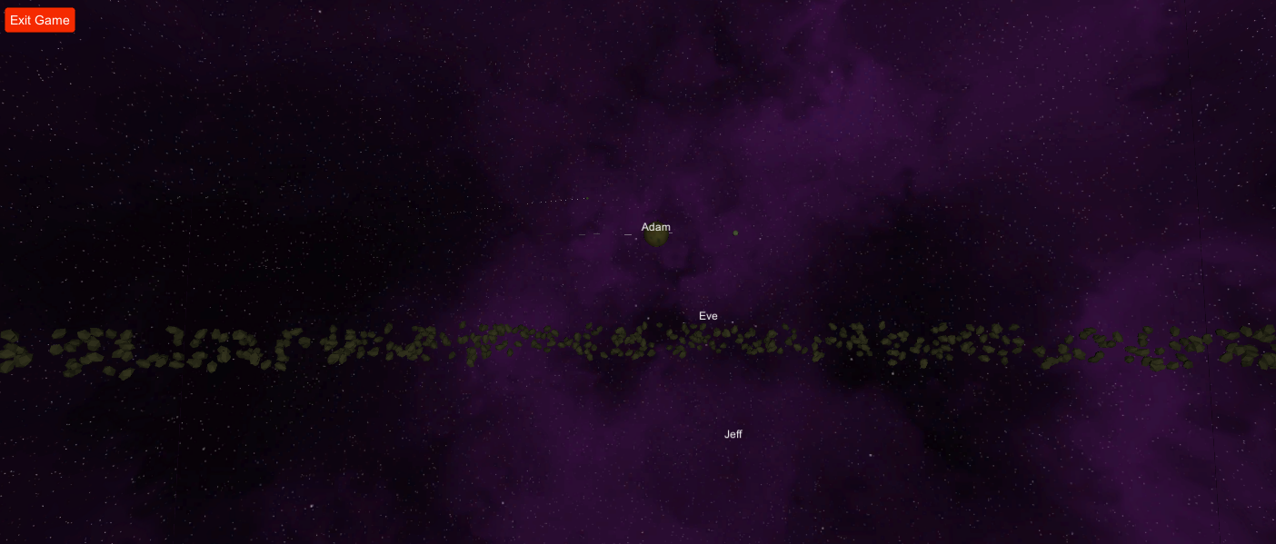

***(In this scene EVE and Jeff nametags tag nothing due to a glitch)***

These name tags needed to be removed as it causes player confusion.

* **Fix Spawn Menu;** “Clarity”

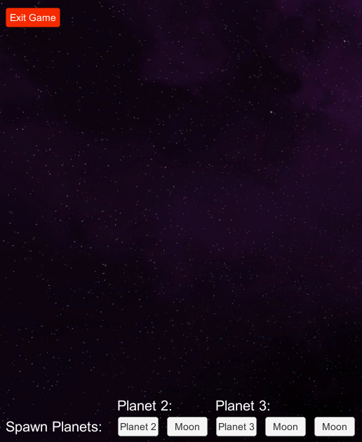 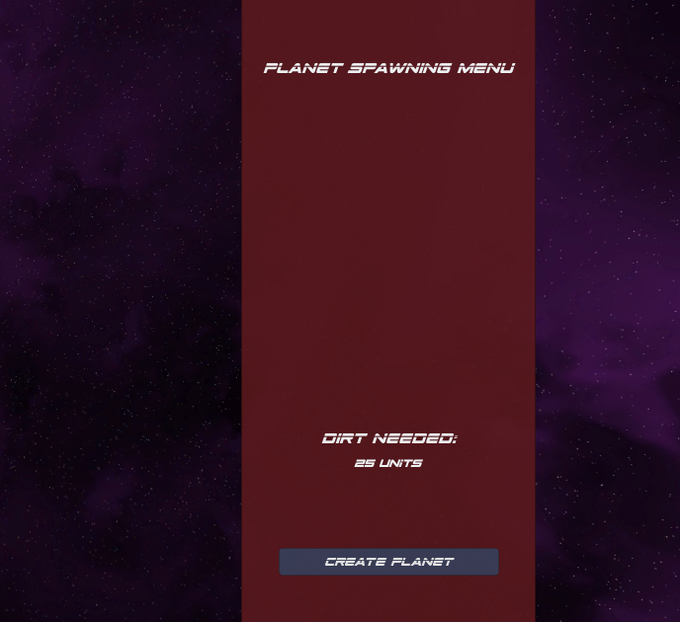

*Before alpha release Alpha Release*

Spawn menu was originally removed for pre-alpha 2, but now needed to be readded for spawning planets by the player.

* **Pop-up info panel;** “Feedback”

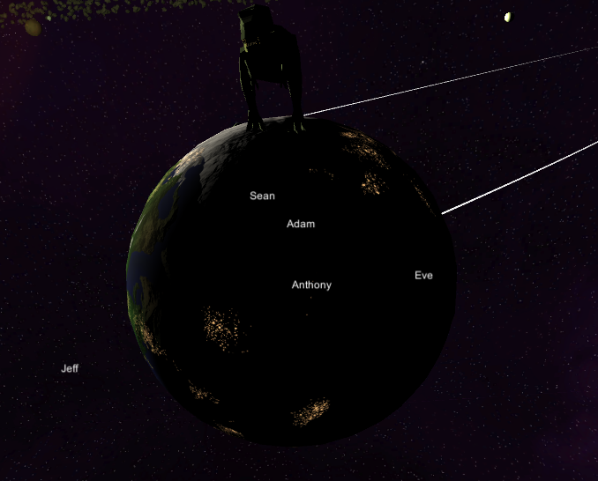 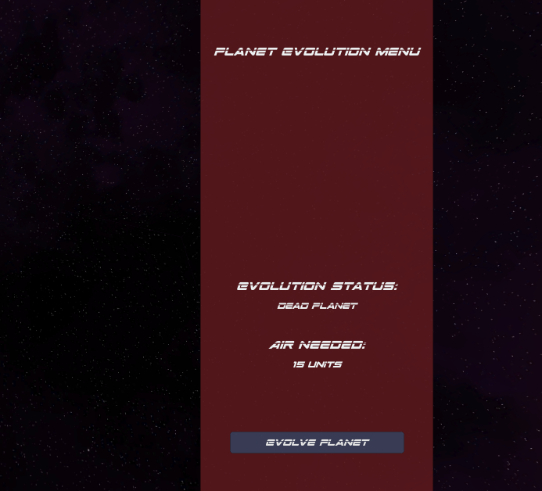

***No info menu before Alpha info panel***

**Menu Popup that displays information about the planet selected**

**Sound Design:**

Game Selected for review: **No Man’s Sky**

Game play viewed:<https://youtu.be/tSFU9L7BRYc>

**Sounds observed:**

1. When cursor goes over selectable menu icon it makes a click

* **Where/When:** Takes place inside of the crafting menu when hovering over selectable item
* **How impacts visuals:** gives a subtle tactile feedback on availability of craftable items.
* **Why taking place:** for audible feedback to player
* **Is it repetitive?:** Slightly if moving around alot, could’ve made the cursor move slower or a timer between clicks.
* **How do you think they made the sound?:** Recorded a clicking sound from some real world object

1. Resource Collecting Sound Effect

* **Where/When:** Takes place when the player destroys asteroids and collects the materials from it.
* **How impacts visuals:** Lets players know that he/she has collected the materials.
* **Why taking place:** for audible feedback to the player.
* **Is it repetitive?:** Depends, if there is a lot of the materials then yes the sound will play until all materials are collected.
* **How do you think they made the sound?:** Vibration sounds of two thin metal pipes hitting each other.

1. Wind sound effects when high up

* **Where/When:** When player character is high up on terrain or in the sky
* **How impacts visuals:** Gives a much bigger sense of height.
* **Why taking place:** To indicate to the player that they’re higher up
* **Is it repetitive?:** No, they seemed to have sourced many clips so that it never sounds like it’s the same effect playing over and over.
* **How do you think they made the sound?:** Recorded wind whooshing outside or past the mic indoors.

1. Footfall sound changes based on terrain

* **Where/When:** Whenever the player steps in any direction and their foot makes contact with the ground.
* **How impacts visuals:** Gives a sense of walking over different types of ground.
* **Why taking place:** without footfalls something would sound off about player movement.
* **Is it repetitive?:** No, they seem to have many different footfall sounds that they choose from random.
* **How do you think they made the sound?:** Recordings of someone stepping on many different types of surfaces. i.e. sand or stone.

1. Suit gives danger notification i.e. “temperature low”

* **Where/When:** Whenever the player is in danger of dying from something, dangerous temperature, low health etc.
* **How impacts visuals:** It gives players an audible notification to the visual health and temperature bars.
* **Why taking place:** In order to give the player a more intuitive sense of what's happening to them since their focus won't always been on player status
* **Is it repetitive?:** No, the events are far enough in between that it doesn't sound repetitive.
* **How do you think they made the sound?:** Recording from some sort of better than Microsoft Sam text to speech device.

1. Ship boost sound

* **Where/When:** When the ship travels faster.
* **How impacts visuals:** It’s an indicator to the players that the ship is moving faster since the area is so big there is nothing to show that it’s moving faster.
* **Why taking place:** To show that the ship is traveling at a faster speed.
* **Is it repetitive?:** Yes, if the player speeds up the ship consistently.
* **How do you think they made the sound?:** Sounds like they recorded the sound of the wind through a pipe.

**Listen to how well balanced all the sounds are in full-out gameplay. Are some sounds too loud or too quiet because they are drowned out by other sounds?**

The volume of the ambient sound in the background will change depending on the area the player is at. When the player is in space mining for materials the ambient sound is drastically lowered compared to when the player is on the planet. The sound from the laser mining tool gets really loud that it drowns out other sounds such as the material collection sounds and sometimes the ship traveling sound.

**Sounds Created for the game:**

**Background sounds:**

* Background music (ambient)
* Ambient Sounds for planet
* Ambient Sounds for Sun

**Sound effects:**

* Explain how the sounds were created. Explain why in the end you accepted or rejected certain sounds.
* The sounds effects were found on sites providing them royalty free.
* We were looking for a lot of sounds that involved UI such as menus popping up, zooming in on planets, and an indicator that an item was collected.
* Many of the sounds that we were originally considering were like this, but we ultimately found many of them too abrupt and aggressive. We wanted the game to have more of a calm vibe to it, and it needed to match the tone of the ambient background music.
* Sound Effects:
  + "UI Confirmation Alert, B4.wav" by InspectorJ (www.jshaw.co.uk) of Freesound.org
    - When the player collects dirt
    - This is like a dinging sound to let the player know that they’ve collected a useful item
  + "Power Up, Bright, A.wav" by InspectorJ (www.jshaw.co.uk) of Freesound.org
    - When the player collects air
    - This sound chimes to signify the player has collected something good
  + “Blip2” by nsstudios
    - When the player opens the menu
    - This is a futuristic selection sound
  + “Spawn space metal / Spaceship door opening” by strexet
    - When the player creates a new planet
    - This sound sounds like the construction of rock materials, which is what a planet is
  + “Teleport.wav” by Sergenious
    - When the player zooms in to a planet
    - We chose this sound to simulate the player traveling quickly to the planet
  + “Menu_Select_00.wav” by LittleRobotSoundFactory
    - When the player toggles the camera options
    - This is just a little click sound that’s gives the player feedback that they changed the camera

**Gameplay:**

**Prototype[Pre Alpha 1]:**

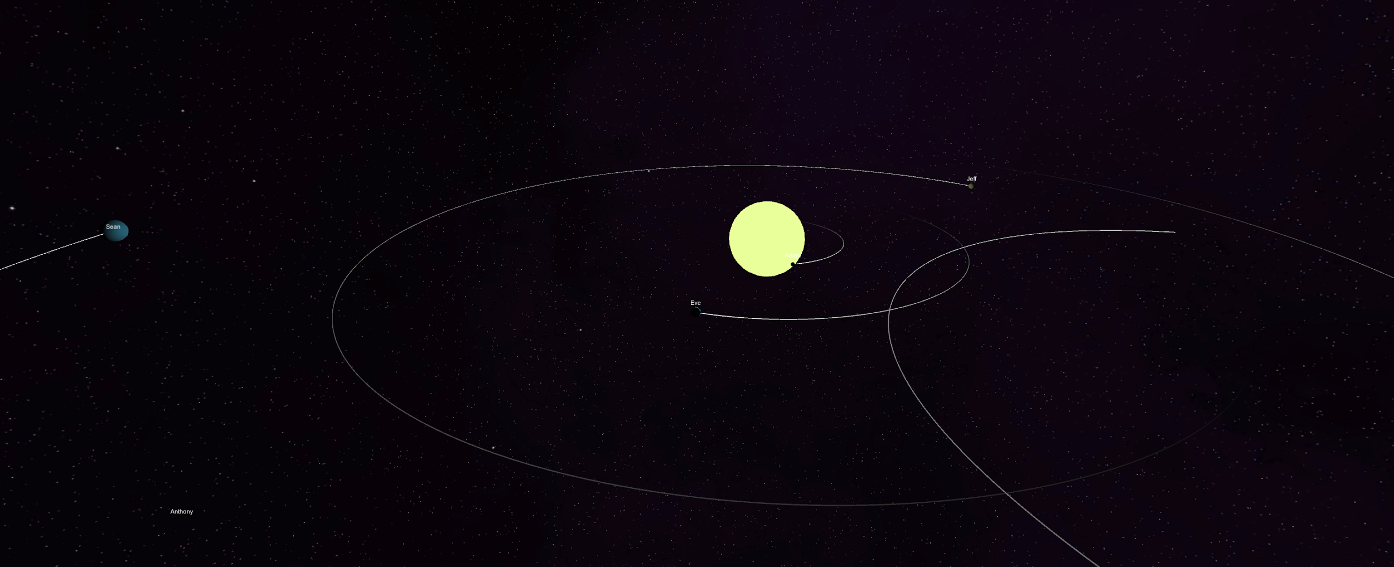

**Pre Alpha 2:**

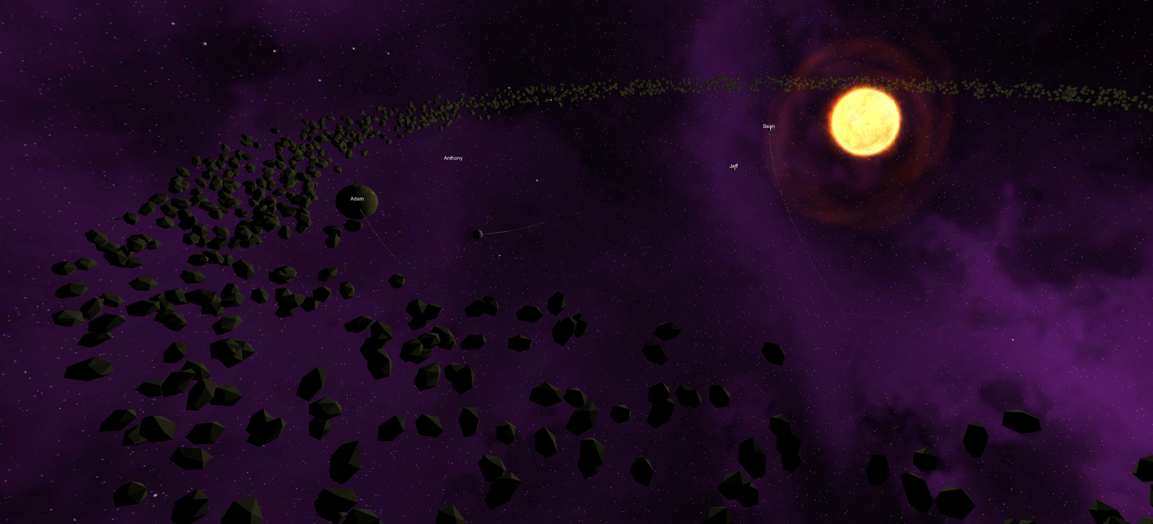

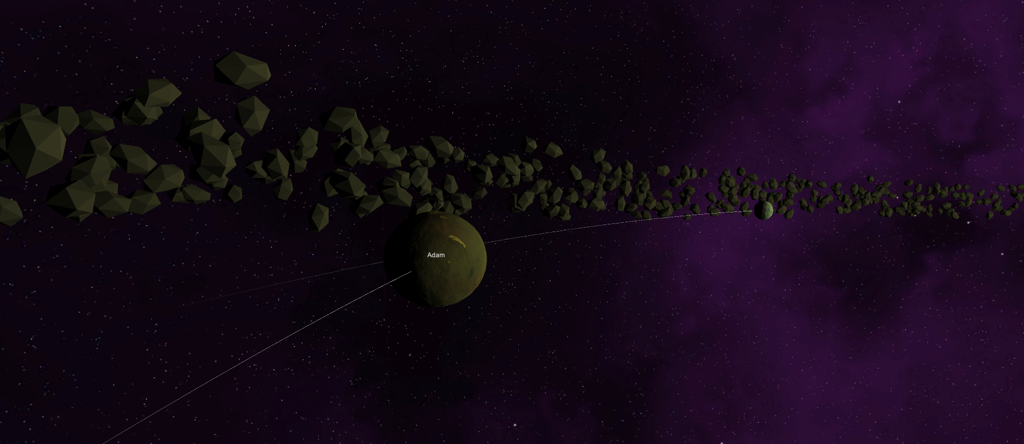

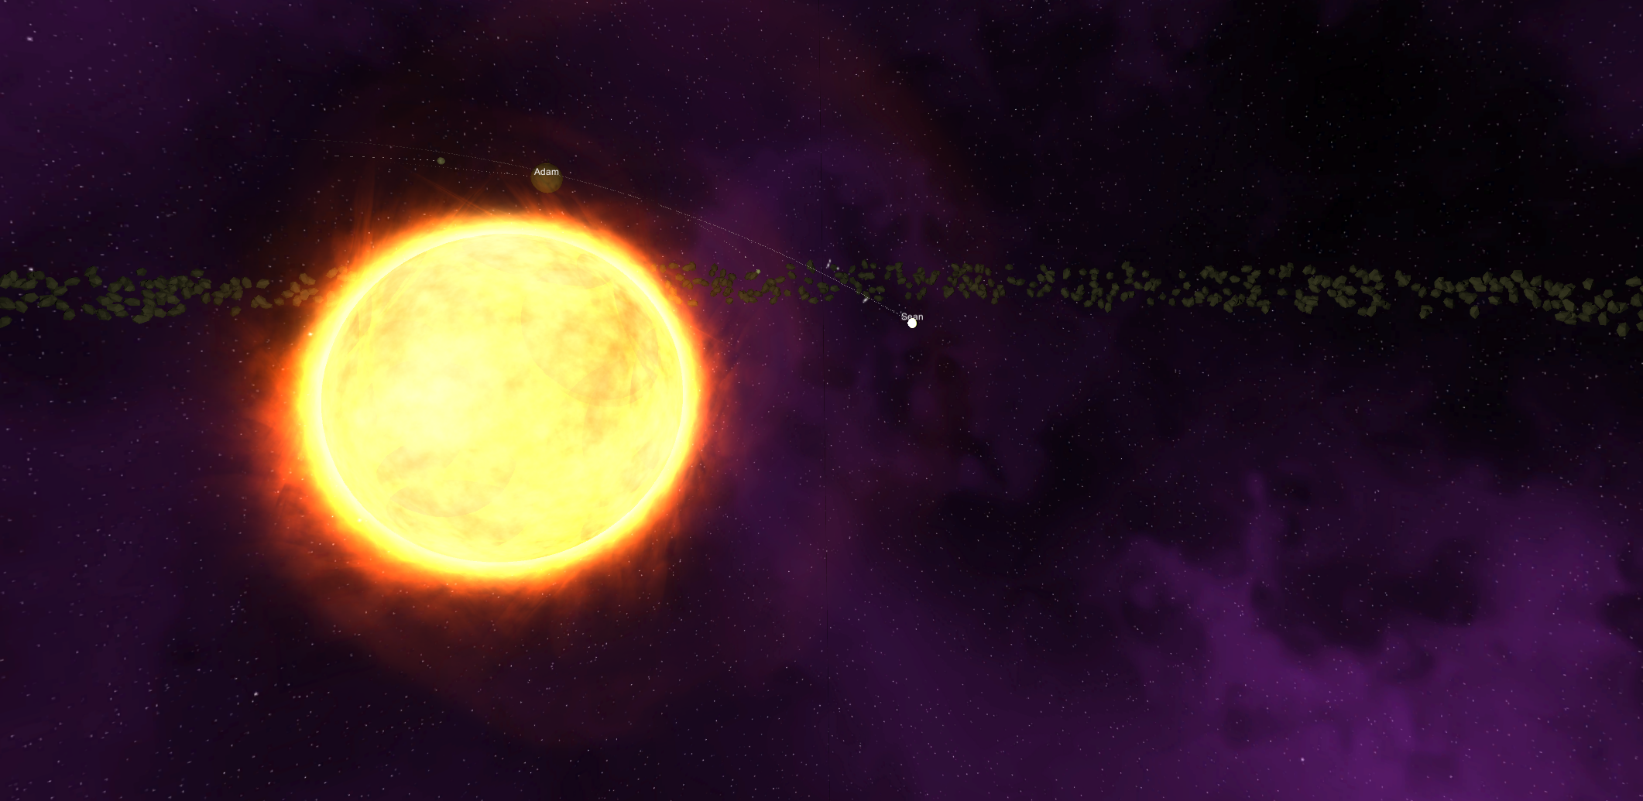

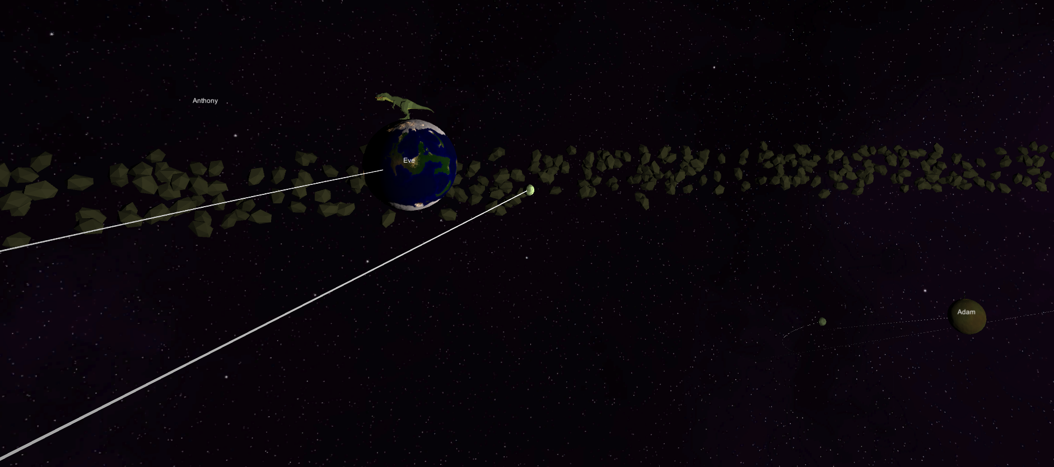

**Level Design:**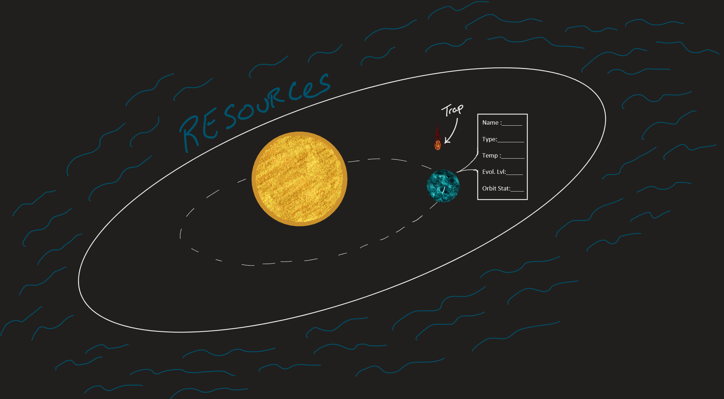

**Level Design Principle:**

**FloorPlan:**

The floorplan consists of a planetary system where the player interacts with celestial objects such as the sun, planets, moons, asteroids, etc. The Player can move out of the planetary system and enter deep space where they are able to gather resources for use in building/improving planets. When the player collects enough resources, the player could select a type of planet and its properties and then set the initial trajectory of its orbit. The planet will be affected by the gravitational pull of the other objects in space. There is no limit to the number of bodies in the planetary system.

**Traps:**

The traps consist of asteroids that randomly enter the planetary systems and cause destruction on the planets. There are also orphan planets that can enter the system and alter the planet's orbits with their gravitational pull, which in turn can cause life on that planet to be wiped out. The player can protect the planets from outside incoming objects by clicking on them in time. This will also give the player resources from the asteroids. The planets are also always in danger of colliding with one another if the orbits are done poorly, and this would cause them to be destroyed.

**Level Components:**

**Puzzles:**

Players will be solving puzzles like setting orbits, avoiding planetary collisions, maintaining evolution, and healthy status of the planet. Evolution and health of the planets can be determined based on their safety from other bodies and whether the planet is located within the Goldilock zone (if it's habitable). Later in the game players will be solving puzzles that are generated by them like what/where to gather the materials and what planets they might have to give up on for others to survive. Any resources gathered can be used to evolve the planets as well as build new ones.

**Level Geometry:**

* Planets
* Stars (Sun like)
* Asteroids
* Gas body

**Characters and Topology for animation:**

* Planets will orbit around a Star
* Planets rotation
* Characters will be bounded by the size we set for the universe
* Player is restricted from entering the planets

**Character Animations:**

* Player flies around in 3 dimensional space
* Player controls a camera that they use to observe and manipulate the planetary systems
* No physical player model/animations
* Alien suffering and dying on the lava planet
* Alien dancing on another planet
* Dinosaur defending itself on the terra planet
* Spaceship flying from planet to planet and another spaceship flying through the asteroid belt avoiding the objects

**Animations:**

* Planets rotation
* Planet evolution growth
* Flying asteroids
* Sun (Solar Flares)

**Physics:**

* The planets are set in calculated elliptical orbits revolving around the star.
* The comet has a tail when it gets close to the star and uses a particle system.
* There’s an asteroid belt that revolves around the star.
* The star has solar flares using particle physics.